Project Title:
An NLP-Based Prototype for Anomaly Detection in Cloud-Generated and Benchmark Cybersecurity Logs

Unit Code and Name:
COIT20265: Networks and Information Security Project

Assessment Title:
Assessment 1
Part B: Individual Reflection and Learning Plan

Student Name:
Nafisa Sultana

Student ID:
12289859

Submitted to:
Unit Coordinator:
Biplob Roy

Mentor:
Ahmedi Azra

Due Date:
30/03/2026

1. Introduction
This personal learning plan describes my goals, skill development, and contribution to the group project. In this project, I am working as the Software Engineer. My main focus is to help develop and integrate the core parts of an NLP-based cybersecurity system. This reflection also helps me understand my current weaknesses and how I can improve my skills during the project.
2. Personal Learning Goals
My main goal in this project is to learn how Natural Language Processing (NLP) can be used in cybersecurity, especially for analysing log data and detecting unusual or suspicious behaviour. I want to improve my ability to design and build a system that includes preprocessing, NLP processing, anomaly detection, and output generation.
I also want to improve my Python programming skills and gain more practical experience with machine learning and NLP tools. This project gives me a good opportunity to apply what I have learned in theory to a real-world problem and improve my problem-solving skills.

3. Knowledge and Skills Gaps
At the beginning of this project, I realised that I do not have much experience in applying NLP techniques to cybersecurity data, especially when working with log files. I need to improve my understanding of text preprocessing, feature extraction methods like TF-IDF and embeddings, and how anomaly detection models work.
I also found that I have limited experience in connecting different parts of a system into one working solution. In addition, I need to improve my debugging skills and system design understanding so that I can make sure all parts of the system work properly together.
4. Strategies for Skill Development
To improve my skills, I plan to learn through both theory and practice. I will go through online tutorials, documentation, and learning resources related to NLP and cybersecurity. I will also practice coding regularly so that I can better understand preprocessing, text representation, and model implementation. To support my learning, I have enrolled in online courses related to Natural Language Processing and Python for Cybersecurity. These courses provide practical examples and help me understand how to work with text data and apply machine learning techniques. These courses are helpful for my project because they show me how to process log data, apply NLP techniques such as text representation, and use Python to build models for anomaly detection.
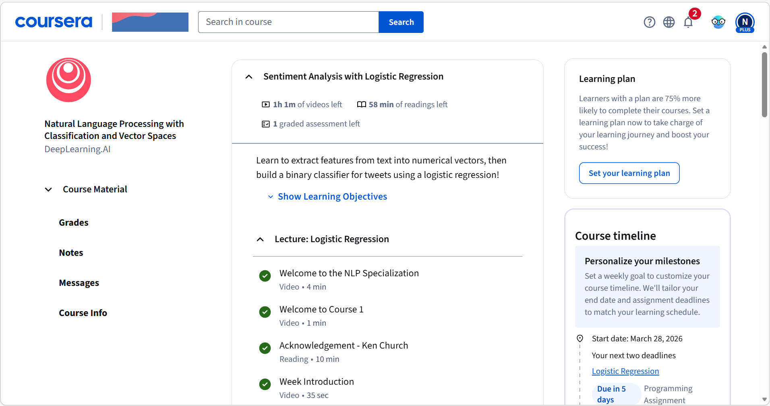
Figure 1: NLP Course Learning Dashboard
This figure shows my enrolment and progress in a Natural Language Processing course, which helps me improve my understanding of text processing and feature extraction used in the project.

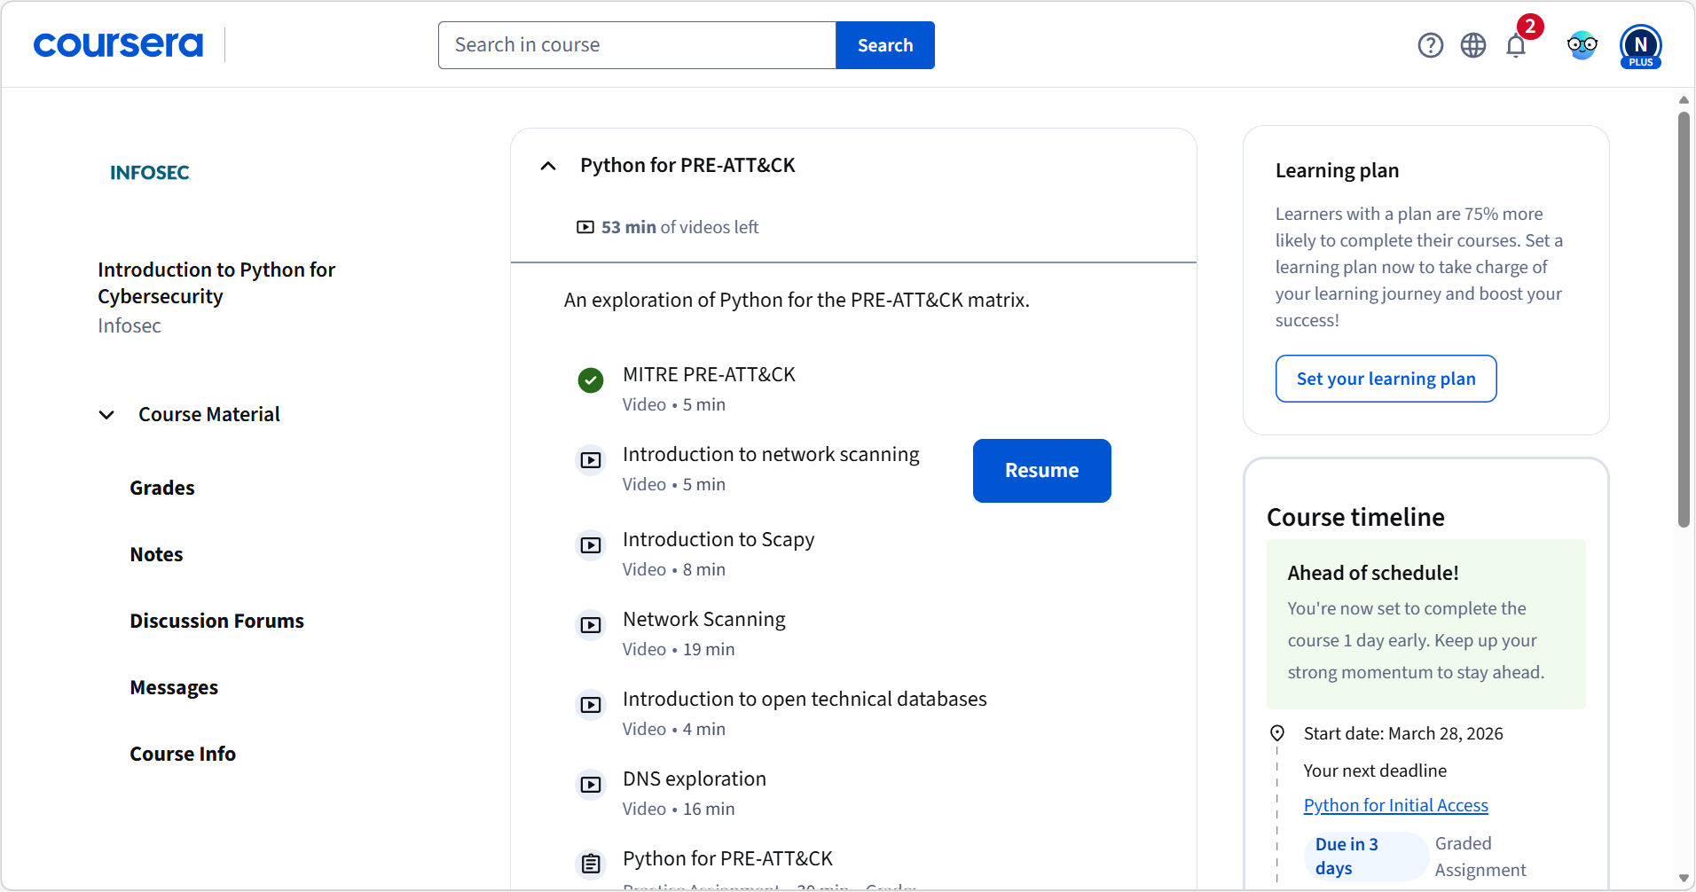
Figure 2: Python for Cybersecurity Course Learning Dashboard
This figure shows my enrolment and progress in a Python for Cybersecurity course, which helps me develop programming and security-related skills needed for the project.
I will also learn from my team members by discussing ideas and sharing knowledge. Feedback from the lecturer will also help me improve my work during the project.
5. Planned Contribution to the Team
As the Software Engineer, I will mainly focus on developing and connecting the core parts of the system. This includes building the preprocessing pipeline, linking the NLP representation layer, and integrating the anomaly detection model with the output.
I will also help with testing and debugging to make sure the system works correctly. I will take part in team discussions and help with system design decisions so that our final system matches the proposed architecture.
6. Professional Responsibility and Ethical Considerations
During this project, I will make sure to complete my tasks on time and contribute properly to the team. I will communicate clearly with my group members and respect everyone’s ideas.
I also understand that working with cybersecurity data requires responsibility. I will make sure that data is handled properly and that no sensitive information is misused. I will also follow academic integrity rules by properly referencing sources and checking any AI-generated content before using it.

